Installation Guide

1 Installation Method - GitHub

  - Access to the Project on GitHub Repository
Link: https://github.com/zxianyap142857/Cybersecurity-Browser-Extension
  - On the GitHub Repository Site. Click on the Code and Download the zip from GitHub.
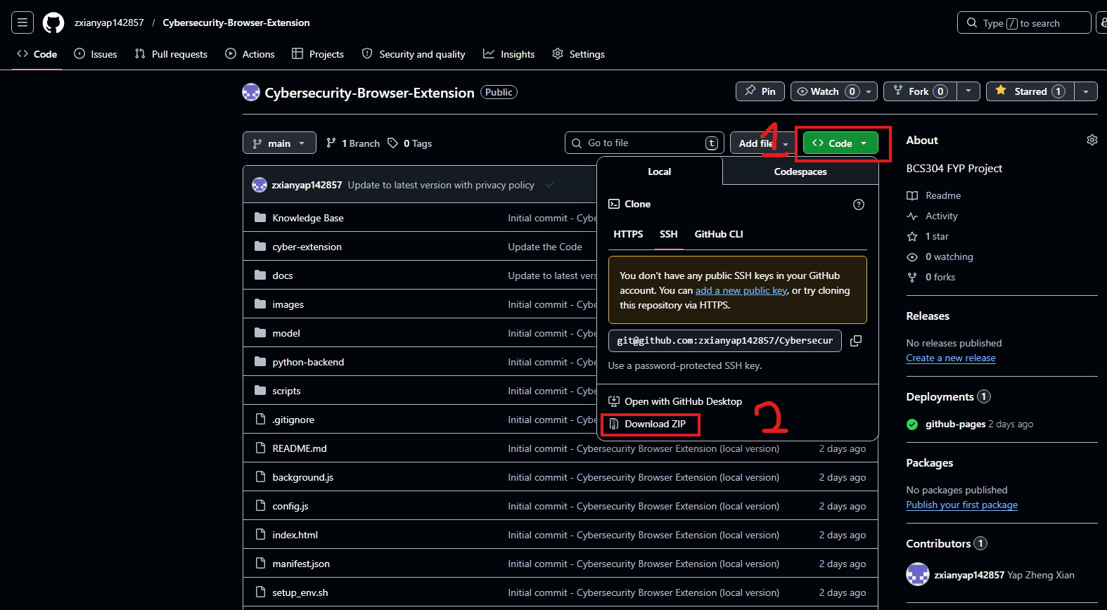

  - Extract the “Cybersecurity-Browser Extension” Folder to any desire directories.
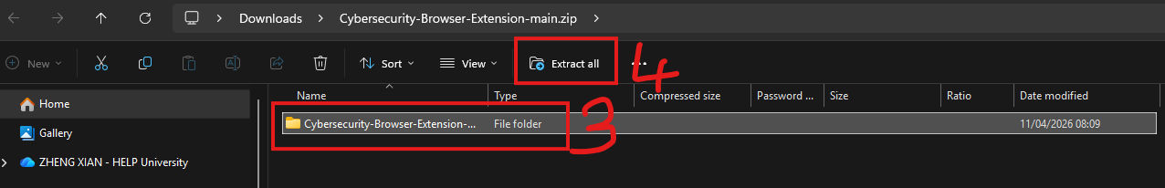
  - Open the Chrome, EDGE Browser and click on the Icon on Step 5 and Select the Extension Feature and Manage Extension.
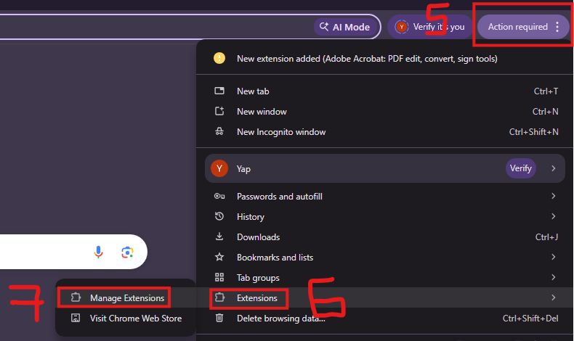

  - In Extension Management Enable the Developer Mode and Click on Load Unpack. Top(Chrome), Edge (Bottom).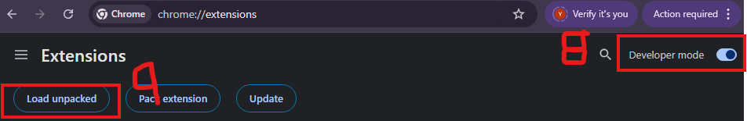
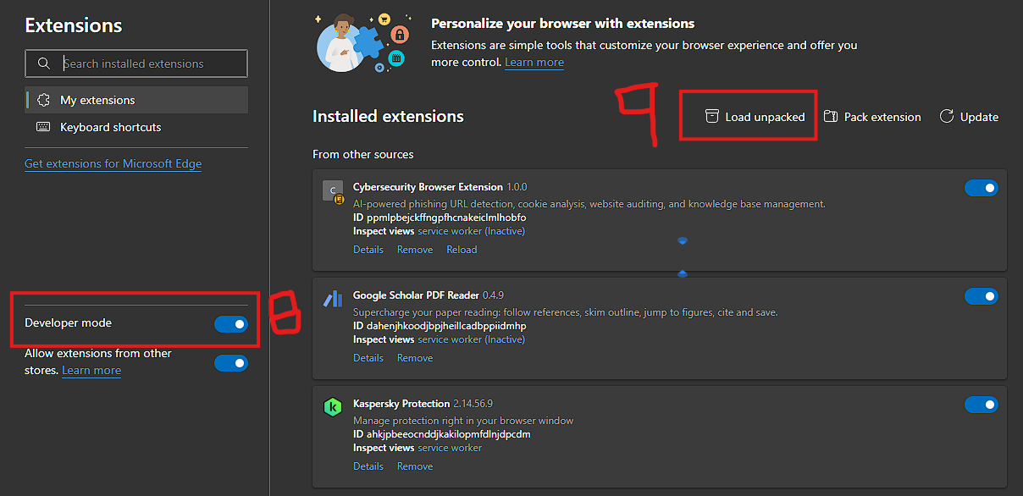

  - Select the “Cybersecurity-Browser-Extension” Folder and Press Select Folder Button to load Project.
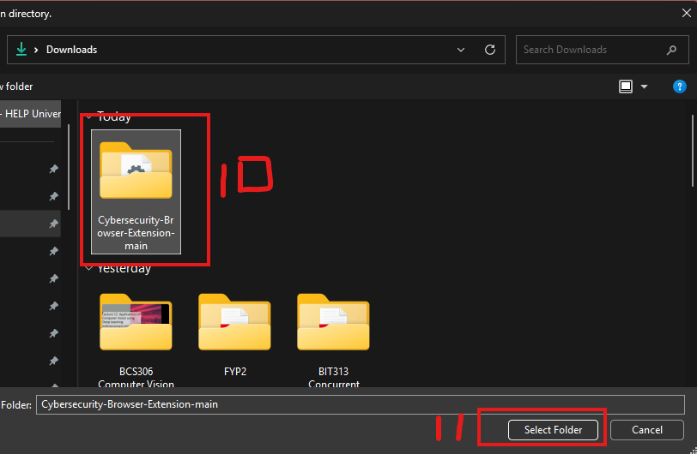
  - After loading the Extension, the Cybersecurity Browser Extension will displayed shown as diagram and User must toggle switch before using it.
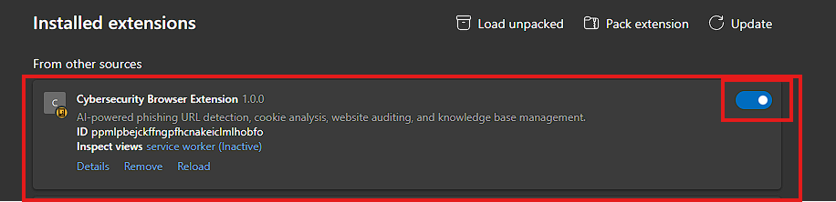
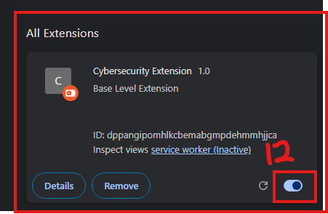
  - Back to Navigation Pannel on the Top Right Section. Click on the Puzzle Icon, the Extension will displayed here. User can used the programme by Clicking it .While the Pin Functionalities Help User for Fast Navigation.
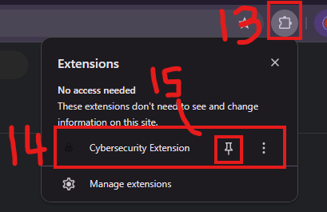

  - The Programme icon will pinned on top of Browser Bar. And User can use the program by clicking the Icon to use it on any website.
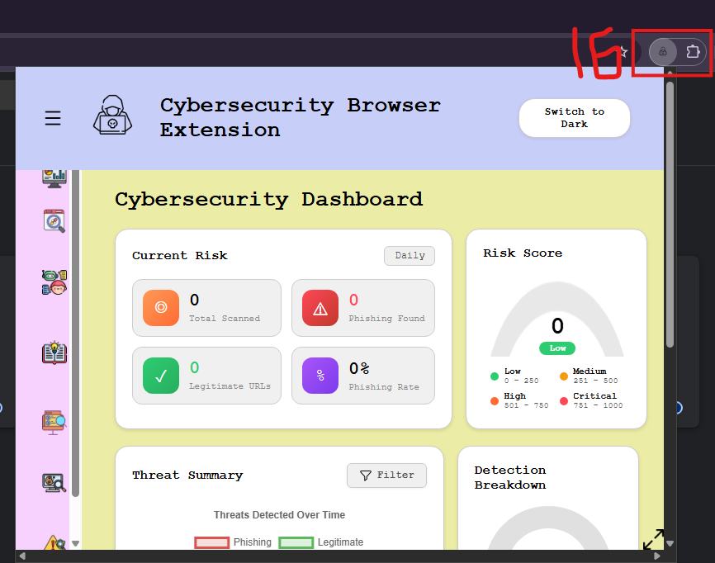
  - The Programme is ready to used. Good Luck!

2 Installation Method– Chrome Web Store

- Access to below link in Chrome or EDGE to install the Extension.
Link:https://chromewebstore.google.com/detail/cybersecurity-browser- ext/ibeabpkkegelecoogmnbhbibkpjndpod
- Click on the “Add to Chrome” and the Extension is ready to used it.
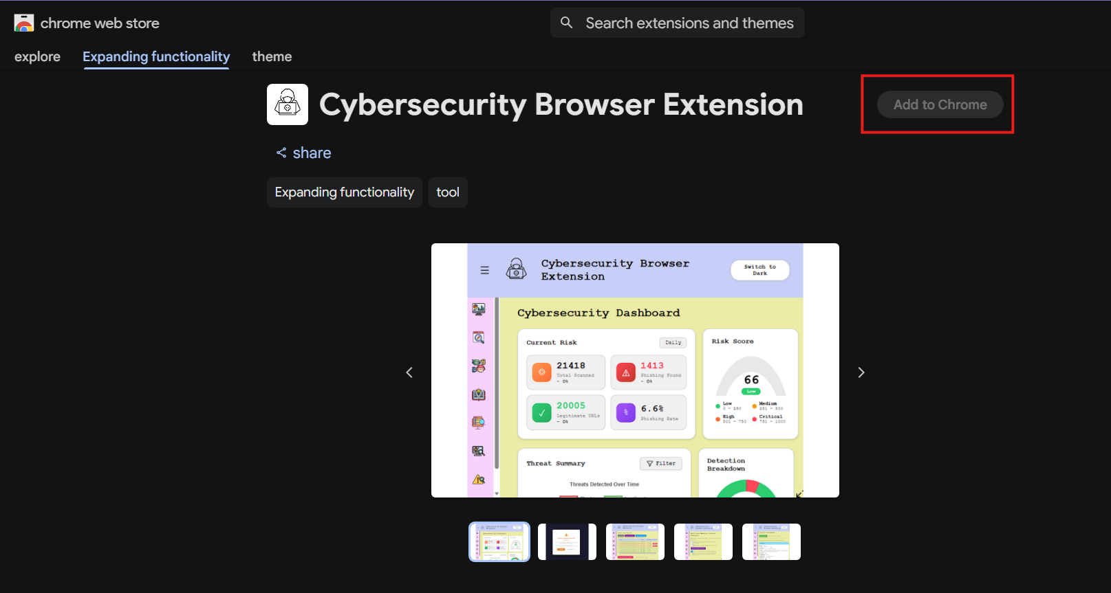
- You have been successfully installing Cybersecurity Browser Extension! Woo-Hoo!

